CS 224 – LAB 1

4-Bit Synchronous Up–Down Counter

Student Details
- Name: TODO: Fill
- Roll No: TODO: Fill
- Group Number: TODO: Fill
- Date: TODO: Fill

Please note:
Students must be able to explain the code they submit (whether provided or written by them).
If a student cannot explain a component, marks for that component will not be awarded even if it works.
⚠ No marks will be awarded if the block diagram is not shown.

1. Block Diagram (2 marks)

Requirement
Draw the IF / ID stage datapath of a RISC-V processor
📌 Use combinational blocks (decoder, mux, logic) and sequential blocks (registers).
TODO: Paste hand-drawn block diagram image here
☑ Instruction decode shown
☑ Immediate generation shown
☑ Control signal generation shown
☑ ID → EX register shown
TODO: Paste the image of a hand drawn block diagram here

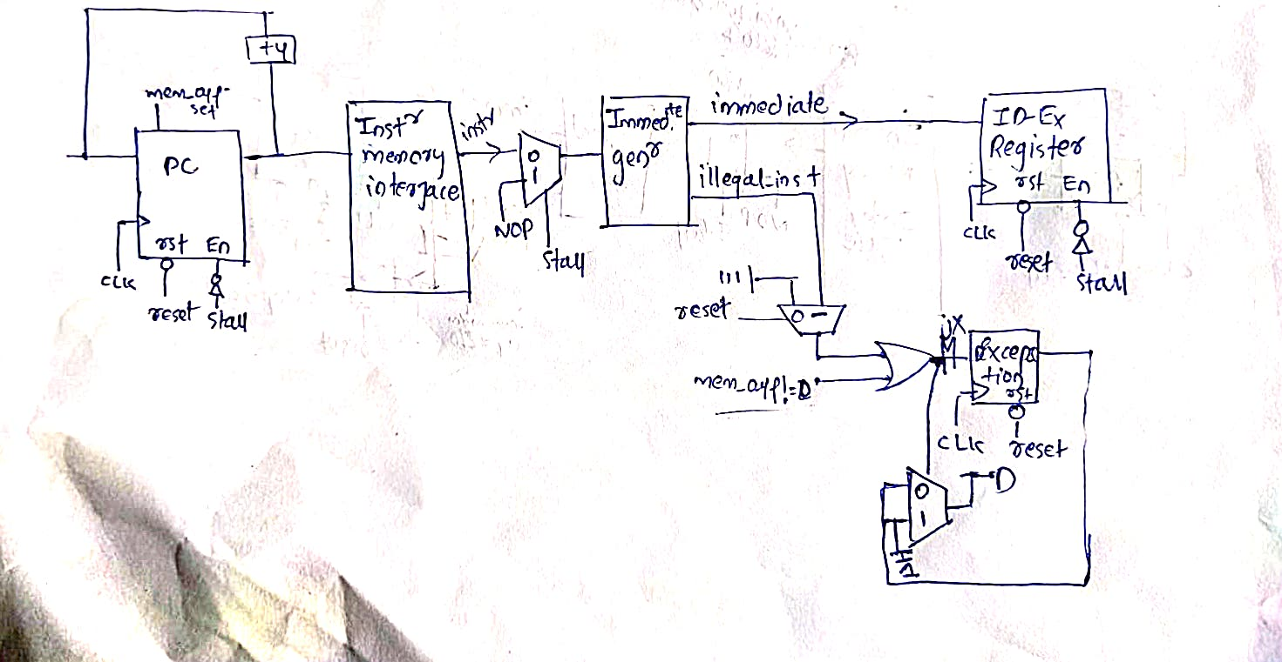

2. Timing Diagram (1.5 marks)

Signals to Show
- clk
- reset
- stall_read_i
- instruction_i
- execute_immediate_w
- illegal_inst_w
- exception

Conditions to Demonstrate
- Reset clears all pipeline registers
- Normal instruction decode
- Stall holds ID → EX register values
- Illegal instruction detection
📌 Minimum 10 clock cycles required
TODO: Paste the image of a hand drawn timing diagram here
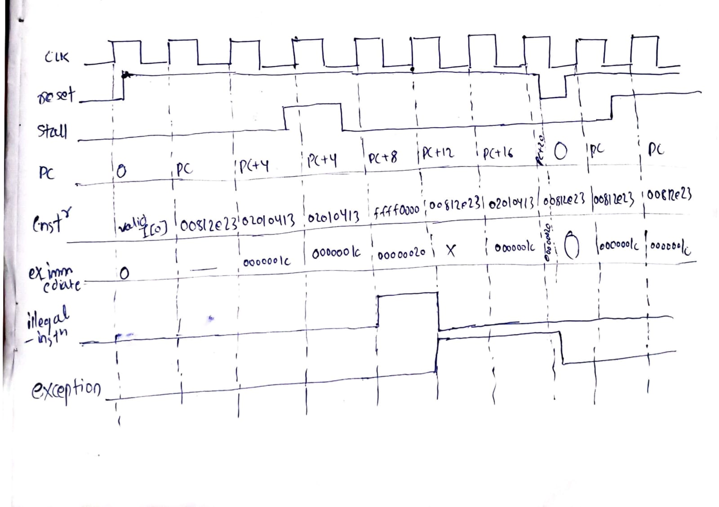

3. Design (2 marks)

Verilog Files Used
- IF_ID.v
- opcode.vh

Design Description
The IF/ID stage:
- Selects instruction or NOP based on stall_read_i
- Decodes opcode and instruction fields
- Generates immediate values for supported RISC-V instruction formats
- Generates control signals
- Detects illegal instructions and misaligned fetches
- Stores decoded values in ID → EX registers
TODO: Add screenshot of your IF_ID.v code (highlighting TODO sections)

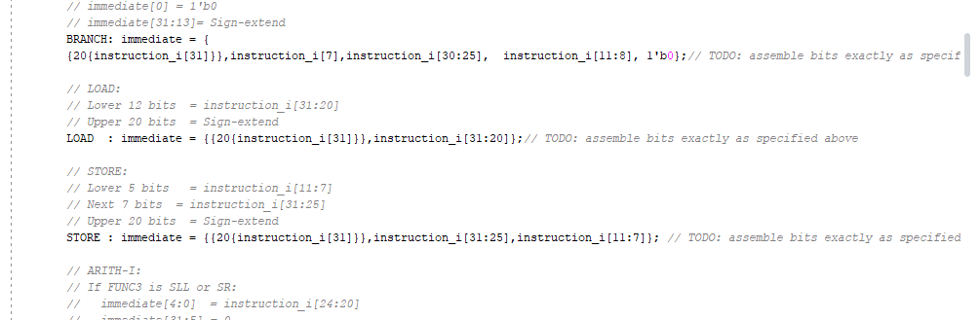

4. Validation Using Simulation (1 marks)

Testbench
- tb_if_id.v

Verification Method
- Trace-driven simulation using inputs.txt
- Outputs logged to outputs.txt
- Compared with expected behavior output_golden.txt

Result
☑ Simulation completed successfully
☑ Output trace matches expected values
TODO: Paste waveform screenshot here

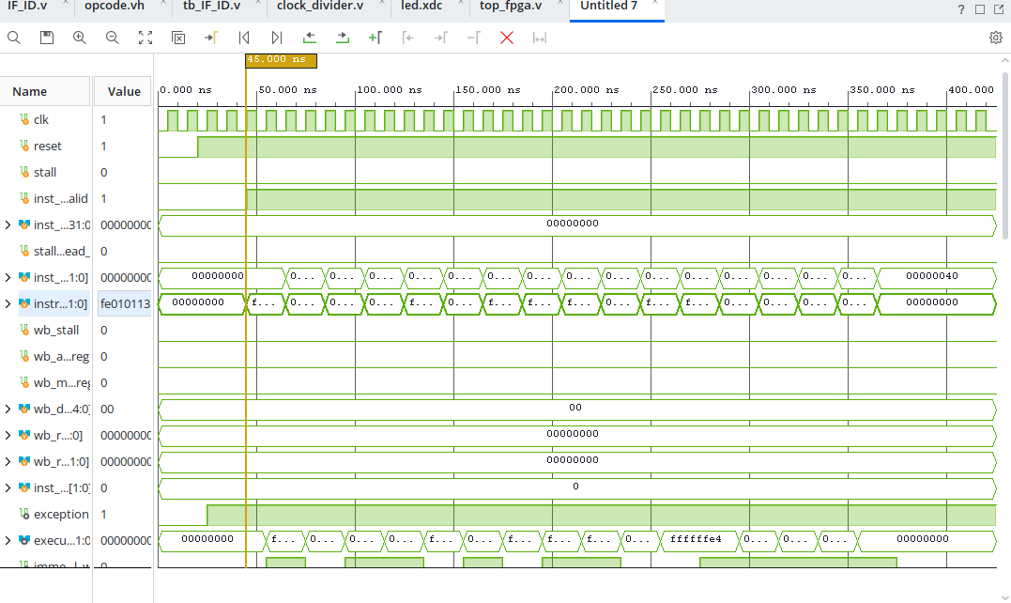

5. FPGA Demo (3 marks)

Hardware Used
- Nexys A7 FPGA Board

Files Used
- top_fpga.v
- clock_divider.v
- inputb.mem
- constraints.xdc

FPGA Mapping
- Clock → On-board 100 MHz clock (via divider)
- Reset → Push button
- Debug Output → execute_immediate_w[15:0] on LEDs

Observation
- Pipeline updates on clock edges
- Reset clears pipeline state
- Immediate values visible on LEDs
- Exception behavior observable
☑ Bitstream generated
☑ FPGA programmed
☑ LED behavior correct
TODO: Add screenshot of the code you have added (in constraints.xdc)
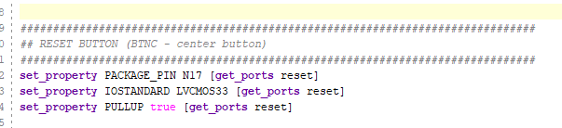
TODO: Add FPGA Screenshot showing the LED output

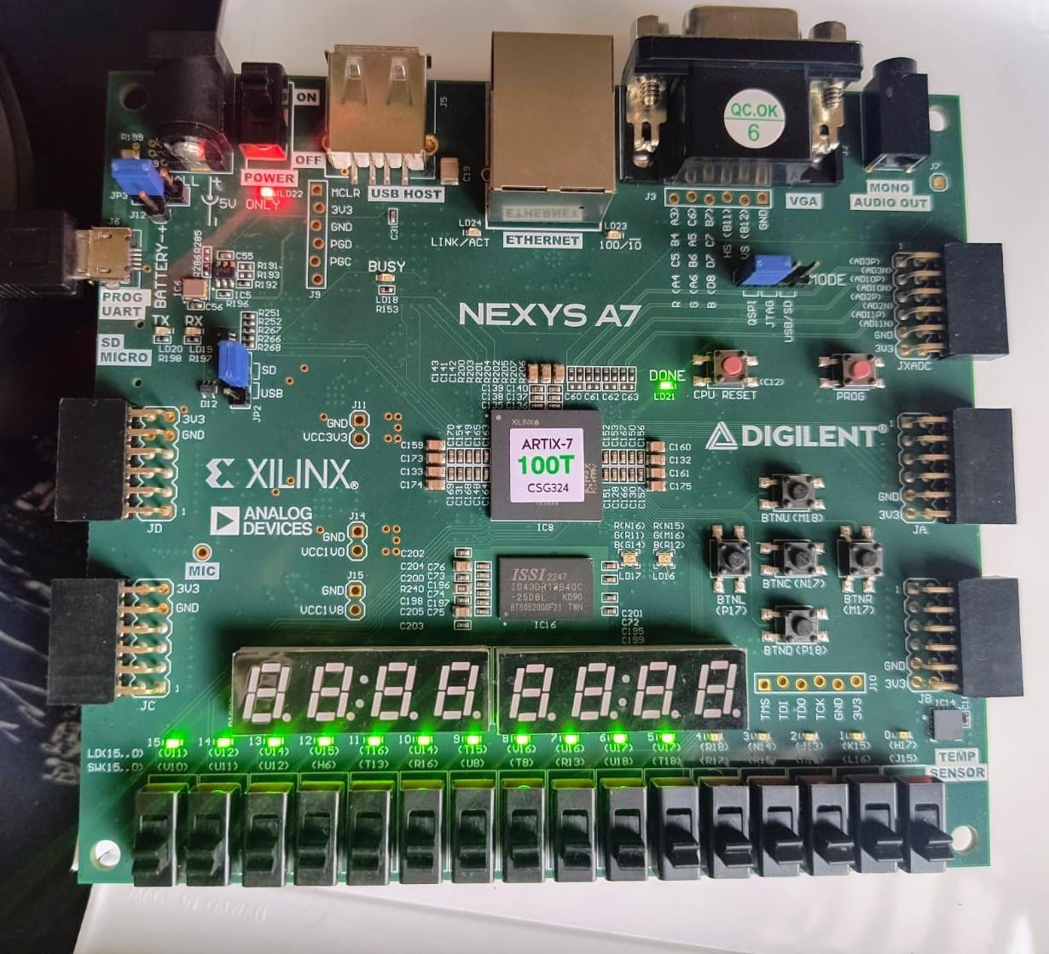

6. Bug Identification (0.5 mark)

Bug Identified / Explained / Fixed

TODO: Briefly describe the bug identified during evaluation
Exception at 1 on ill_inst and retains at 1, if not resetted.
some connection are not connected.
☑ Bug correctly identified
☑ Explanation / fix provided

